Screenshot

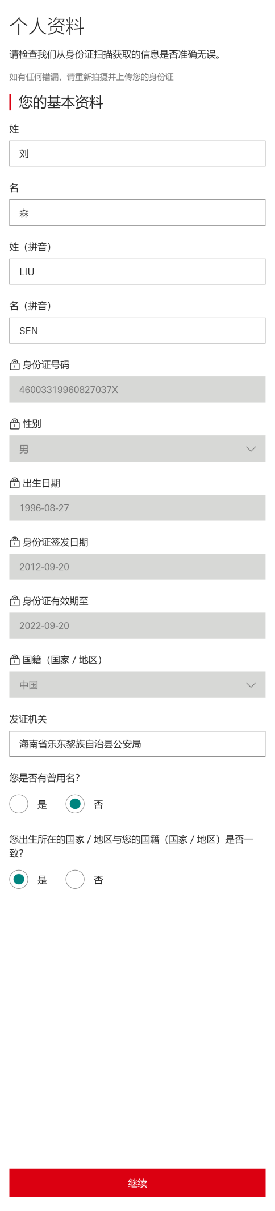

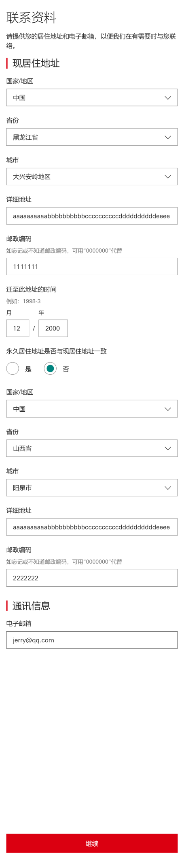

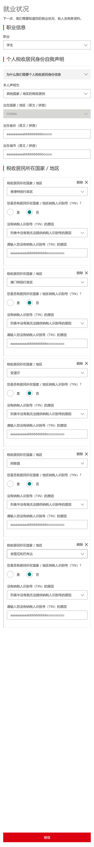

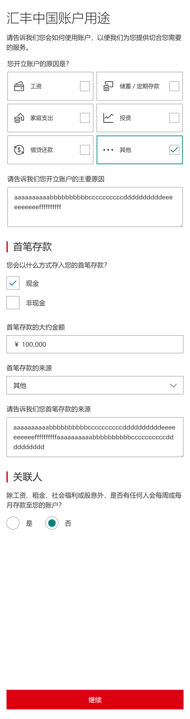

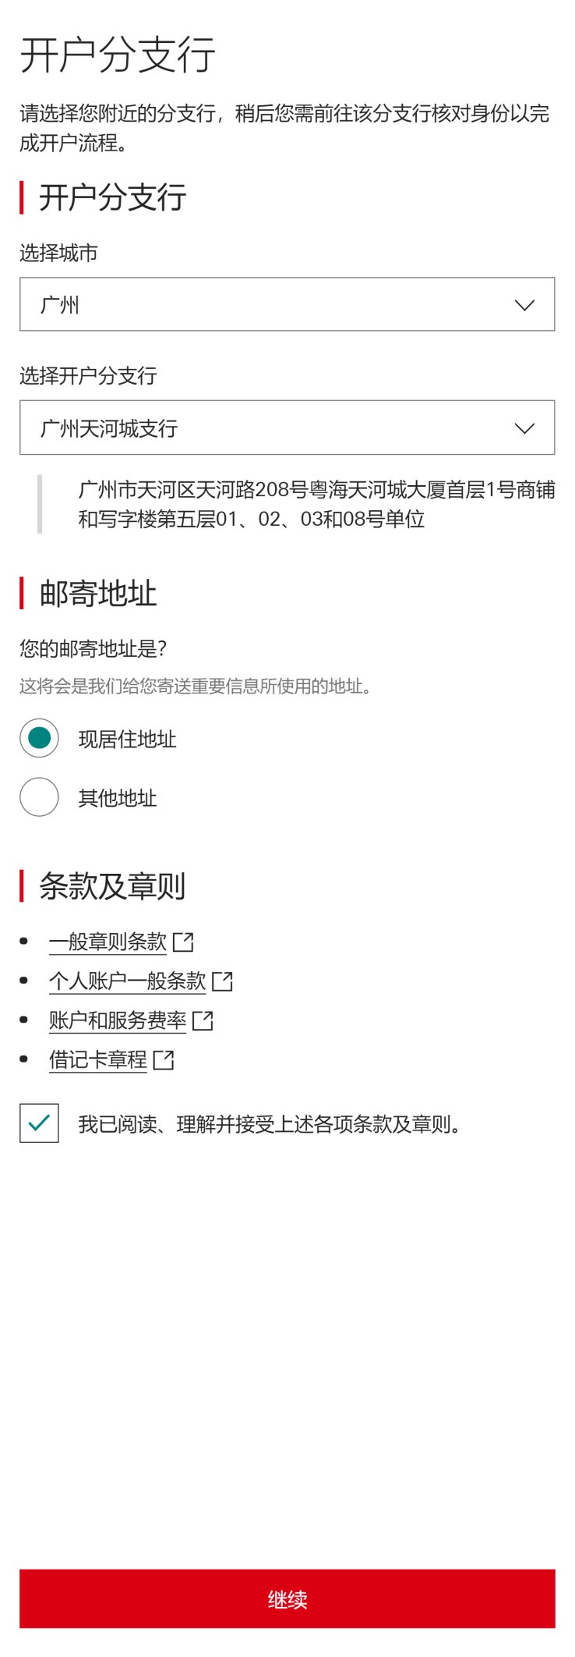

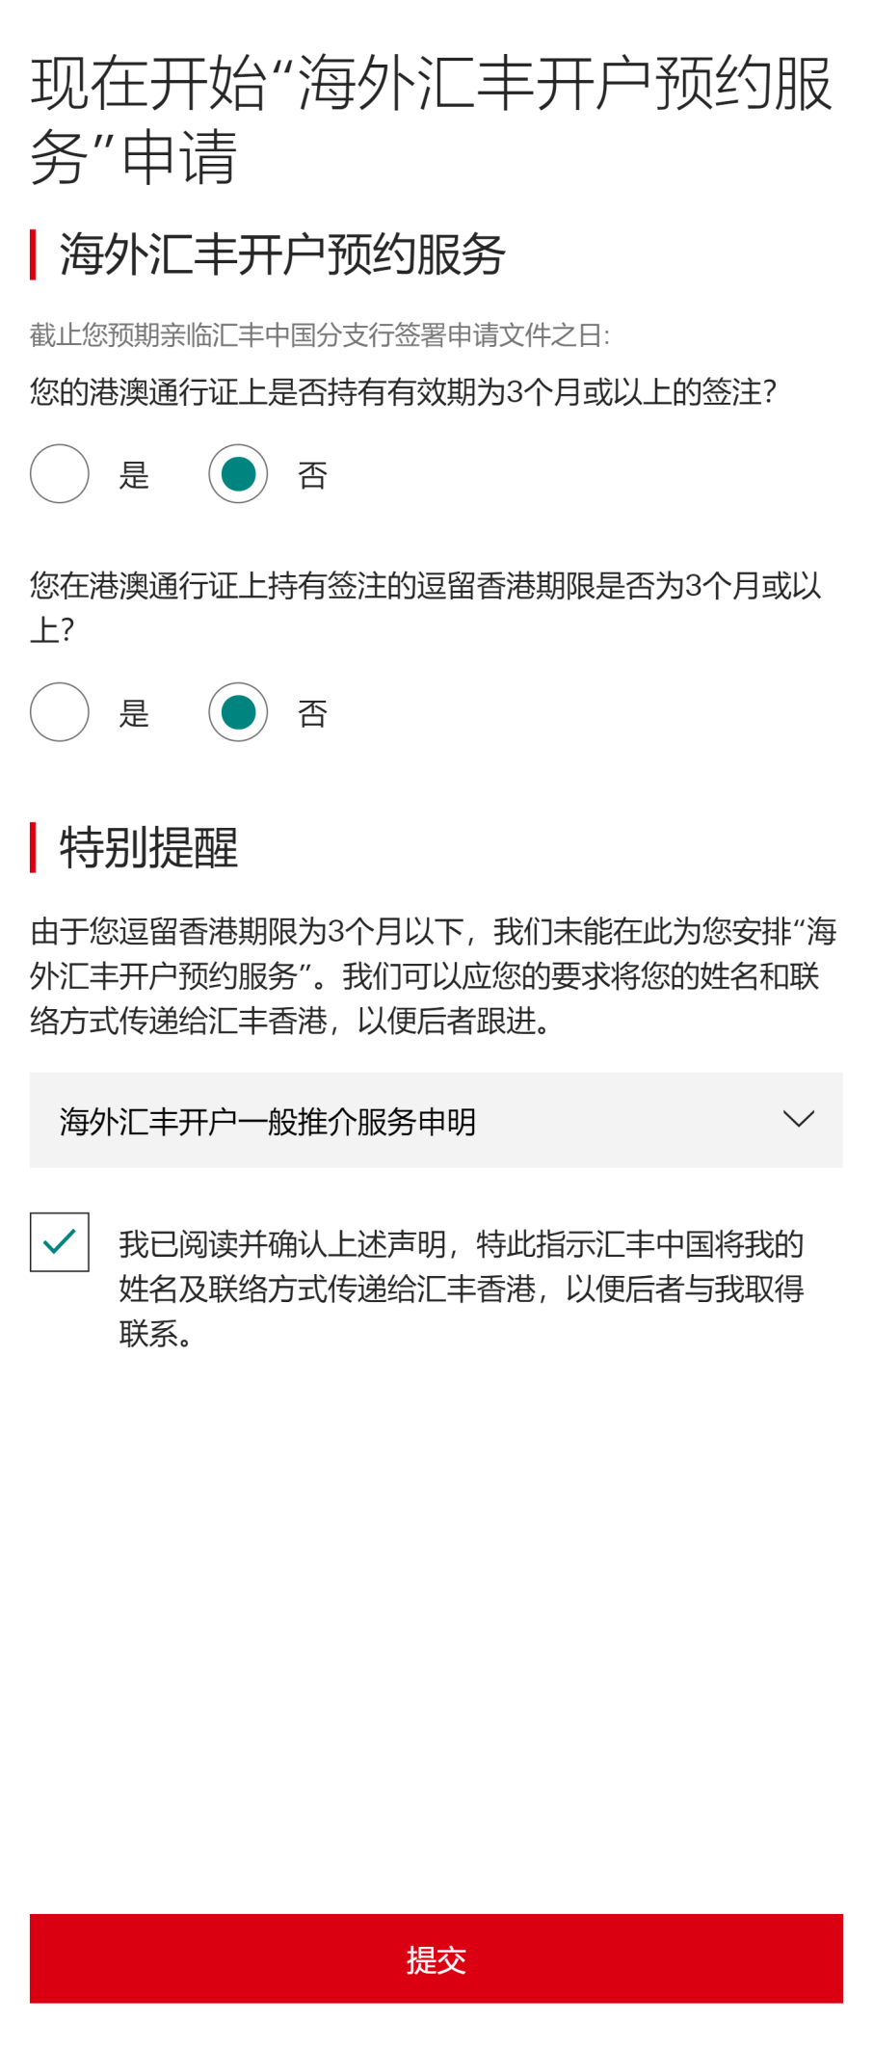

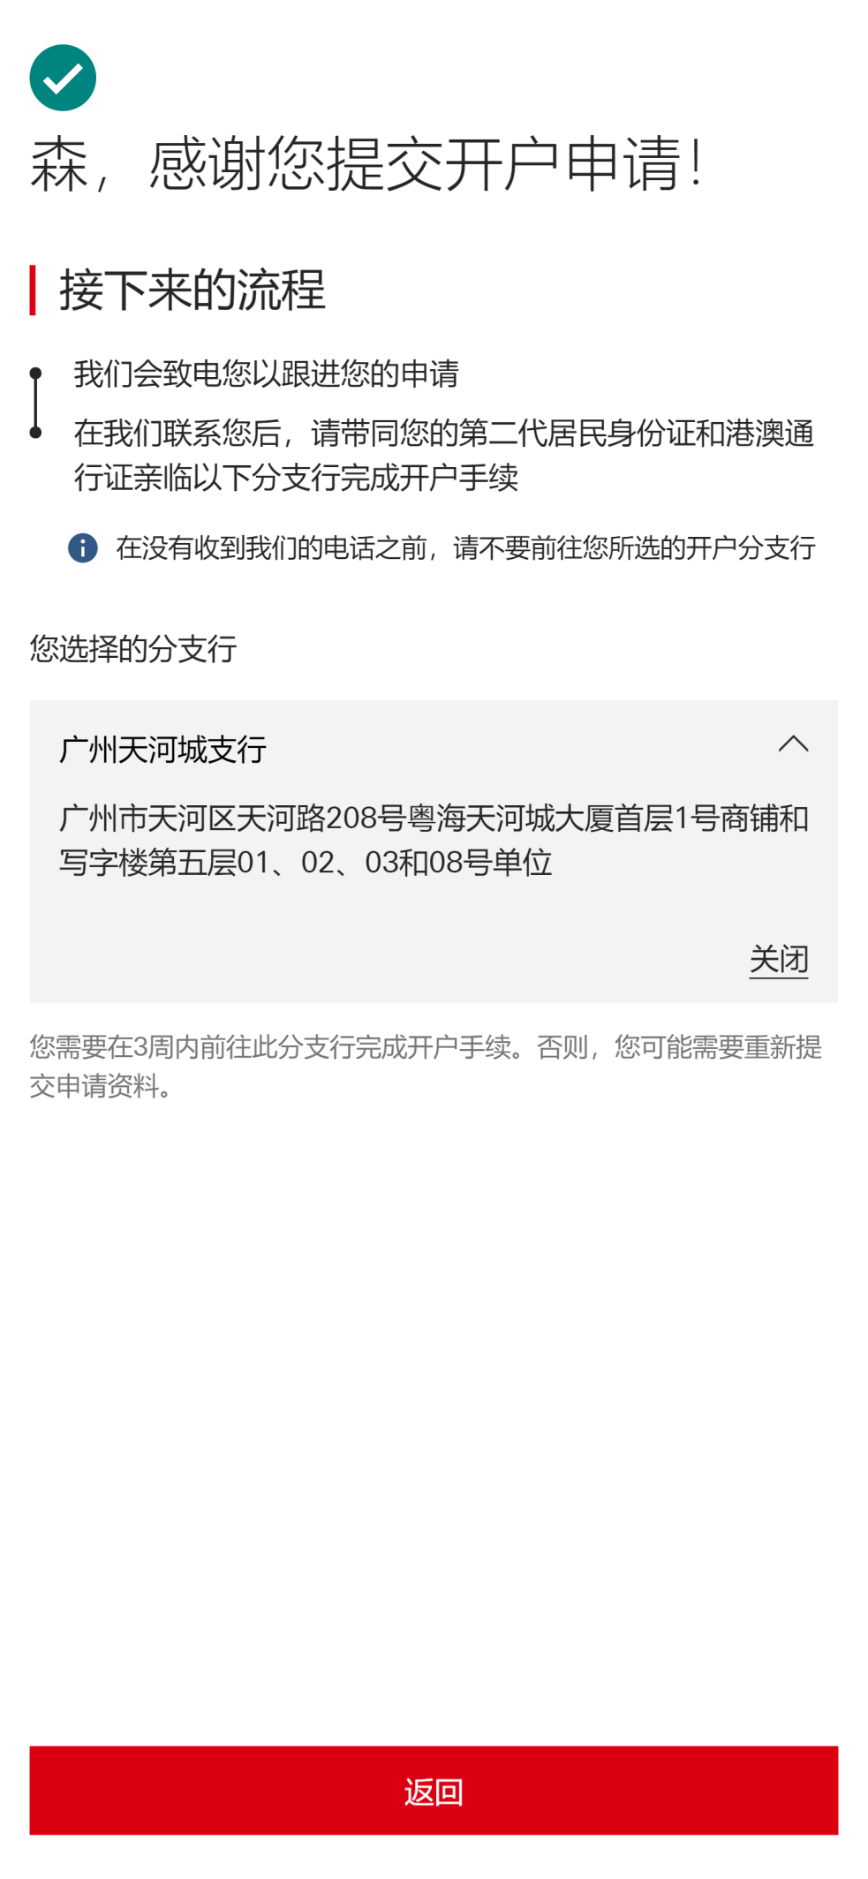

Request body

{"customerLanguage":"zh_CN","checksDetails":[{"checkType":"AGE_CHECK","status":"NO_HIT","profileId":"AGE_CHECK_NO_HIT","codeList":[]},{"checkType":"SCC_INDUSTRY_CHECK","status":"NO_HIT","profileId":"SCC_INDUSTRY_CHECK_NO_HIT","codeList":[]},{"checkType":"SANCTION_LOCATION","status":"NO_HIT","profileId":"SANCTION_LOCATION_NO_HIT","codeList":[]},{"checkType":"RESIDENTIAL_ADDRESS_CHECK","status":"NO_HIT","profileId":"RESIDENTIAL_ADDRESS_CHECK_NO_HIT","codeList":[]},{"checkType":"TAX_RESIDENCE_CHECK","status":"HIT","profileId":"SCC_INDUSTRY_CHECK_HIT","codeList":[]},{"checkType":"CONNECTED_PARTY_CHECK","status":"NO_HIT","profileId":"CONNECTED_PARTY_CHECK_NO_HIT","codeList":[]},{"checkType":"US_INDICIA_PRE_CHECK","status":"NO_HIT","profileId":"US_INDICIA_PRE_CHECK_NO_HIT","codeList":[]}],"consents":[{"consentCode":"CONSENT_T_AND_C","checked":true,"checkTime":"2020-02-17T10:17:21.562Z[UTC]"}],"applicationId":"5e4a64e44a3bace8ff3dafc3","personalDetails":{"customerNames":[{"nameType":"LOCAL","firstName":"森","lastName":"刘","fullName":"刘森"},{"nameType":"PRIMARY","firstName":"SEN","lastName":"LIU","fullName":"SEN LIU"}],"gender":"MALE","dateOfBirth":"1996-08-27","nationalityDetails":{"hasMultipleNationalities":false,"nationality":"CN","nationality2":null,"nationality3":null},"identificationDocument":{"documentType":"IDENTITY_CARD","documentReference":"46003319960827037X","placeOfIssue":"海南省乐东黎族自治县公安局","startDate":"2012-09-20","expiryDate":"2022-09-20"},"countryOfBirth":"CN","title":"MR","residentialStatus":{"hasPermanentResidencyInCountry":true},"countryOfResidence":null,"maritalStatus":null},"contactDetails":{"telephoneNumbers":[{"number":"13632219949","countryCode":"86","telephoneNumberType":"MOBILE"}],"emailAddressList":[{"emailType":"PERSONAL","emailAddress":"jerry@qq.com"}],"addresses":[{"addressType":"HOME_ADDRESS","addressLine1":"中国","addressLine2":"黑龙江省","addressLine3":"大兴安岭地区","addressLine4":null,"addressLine5":"aaaaaaaaaabbbbbbbbbbccccccccccddddddddddeeee","postalCode":"1111111","atThisAddressSince":"2000-12-01","addressCountry":"CN"},{"addressType":"PERMANENT_ADDRESS","addressLine1":"中国","addressLine2":"山西省","addressLine3":"阳泉市","addressLine4":null,"addressLine5":"aaaaaaaaaabbbbbbbbbbccccccccccddddddddddeeee","postalCode":"2222222","atThisAddressSince":null,"addressCountry":"CN"},{"addressType":"CORRESPONDENCE_ADDRESS","addressLine1":"中国","addressLine2":"黑龙江省","addressLine3":"大兴安岭地区","addressLine4":null,"addressLine5":"aaaaaaaaaabbbbbbbbbbccccccccccddddddddddeeee","postalCode":"1111111","atThisAddressSince":"2000-12-01","addressCountry":"CN"}]},"employmentDetails":{"occupation":"STUDENT","employmentStatus":null,"subOccupation":null,"employmentRole":null,"jobTitle":null,"industry":null,"employerName":null,"employerAddress":null},"financialDetails":{"incomePeriod":"P1Y","grossIncome":null,"otherIncome":null,"socialWelfareEligible":null,"taxResidencyInfo":{"taxResidentType":"IN_FOREIGN_COUNTRY","taxResidentCountryOfBirth":"CN","taxResidentProvinceOfBirth":"aaaaaaaaaabbbbbbbbbbccccc","taxResidentCityOfBirth":"aaaaaaaaaabbbbbbbbbbccccc","taxResidencyDetails":[{"countryOfTaxResidency":"HK","taxDocumentIdNumber":null,"reasonForNoTIN":"OTHERS-aaaaaaaaaabbbbbbbbbbcccccccccc"},{"countryOfTaxResidency":"MO","taxDocumentIdNumber":null,"reasonForNoTIN":"OTHERS-aaaaaaaaaabbbbbbbbbbcccccccccc"},{"countryOfTaxResidency":"AD","taxDocumentIdNumber":null,"reasonForNoTIN":"OTHERS-aaaaaaaaaabbbbbbbbbbcccccccccc"},{"countryOfTaxResidency":"AE","taxDocumentIdNumber":null,"reasonForNoTIN":"OTHERS-aaaaaaaaaabbbbbbbbbbcccccccccc"},{"countryOfTaxResidency":"AG","taxDocumentIdNumber":null,"reasonForNoTIN":"OTHERS-aaaaaaaaaabbbbbbbbbbcccccccccc"}]}},"accountUsage":{"hasConnectedParties":false,"connectedPartiesDetails":{"hasRegularDeposit":null,"frequencyOfDeposit":"P1M","approximateDepositAmount":null},"accountPurpose":["OTHERS"],"reasonForAccountOpening":"aaaaaaaaaabbbbbbbbbbccccccccccddddddddddeeeeeeeeeeffffffffff","firstDepositDetails":{"initialFundsTransferProcess":"CASH","initialFundsSource":"OTHERS","initialFundsSourceRemark":"aaaaaaaaaabbbbbbbbbbccccccccccddddddddddeeeeeeeeeeffffffffffaaaaaaaaaabbbbbbbbbbccccccccccdddddddddd","fundsOriginationCountry":[],"initialDepositAmount":{"amount":"100000","currency":"CNY"}},"cashWithdrawlAndDepositDetails":{"makesLargeCashDeposits":false,"frequencyOfLargeCashDeposits":"P1M","numberOfLargeCashDeposits":0,"approximateLargeCashDepositsAmount":null,"makesLargeCashWithdraws":false,"frequencyOfLargeCashWithdraws":"P1M","numberOfLargeCashWithdraws":null,"approximateLargeCashWithdrawsAmount":null},"internationalPaymentsDetails":{"intendToSendOrReceiveInternationalPayments":false,"regularInternationalPaymentDetails":null}},"applicationOpeningAppointment":{"branchMnemonics":"GTT","branchCode":"509,749","branchLocation":"GuangZhou","branchAddress":"广州市天河区天河路208号粤海天河城大厦首层1号商铺和写字楼第五层01、02、03和08号单位"},"secondApplication":{"customerLanguage":"zh_CN","checksDetails":[{"checkType":"AGE_CHECK","status":"NO_HIT","profileId":"AGE_CHECK_NO_HIT","codeList":[]},{"checkType":"SCC_INDUSTRY_CHECK","status":"NO_HIT","profileId":"SCC_INDUSTRY_CHECK_NO_HIT","codeList":[]},{"checkType":"SANCTION_LOCATION","status":"NO_HIT","profileId":"SANCTION_LOCATION_NO_HIT","codeList":[]},{"checkType":"RESIDENTIAL_ADDRESS_CHECK","status":"NO_HIT","profileId":"RESIDENTIAL_ADDRESS_CHECK_NO_HIT","codeList":[]},{"checkType":"TAX_RESIDENCE_CHECK","status":"HIT","profileId":"SCC_INDUSTRY_CHECK_HIT","codeList":[]},{"checkType":"CONNECTED_PARTY_CHECK","status":"NO_HIT","profileId":"CONNECTED_PARTY_CHECK_NO_HIT","codeList":[]},{"checkType":"US_INDICIA_PRE_CHECK","status":"NO_HIT","profileId":"US_INDICIA_PRE_CHECK_NO_HIT","codeList":[]}],"consents":[{"consentCode":"CONSENT_T_AND_C_HK","checked":true,"checkTime":"2020-02-17T10:17:34.446Z[UTC]"}],"applicationId":"5e4a64e44a3bace8ff3dafc3","personalDetails":{"customerNames":[{"nameType":"LOCAL","firstName":"森","lastName":"刘","fullName":"刘森"},{"nameType":"PRIMARY","firstName":"SEN","lastName":"LIU","fullName":"SEN LIU"}],"gender":"MALE","dateOfBirth":"1996-08-27","nationalityDetails":{"hasMultipleNationalities":false,"nationality":"CN","nationality2":null,"nationality3":null},"identificationDocument":{"documentType":"INTERNAL_TRAVEL_DOCUMENT","documentReference":"dummy_document_ref","startDate":"2020-02-17","expiryDate":"2020-02-17","stayRetentionDays":0},"countryOfBirth":"CN","title":"MR","residentialStatus":{"hasPermanentResidencyInCountry":true},"countryOfResidence":null,"maritalStatus":null},"contactDetails":{"telephoneNumbers":[{"number":"13632219949","countryCode":"86","telephoneNumberType":"MOBILE"}],"emailAddressList":[{"emailType":"PERSONAL","emailAddress":"jerry@qq.com"}],"addresses":[{"addressType":"HOME_ADDRESS","addressLine1":"中国","addressLine2":"黑龙江省","addressLine3":"大兴安岭地区","addressLine4":null,"addressLine5":"aaaaaaaaaabbbbbbbbbbccccccccccddddddddddeeee","postalCode":"1111111","atThisAddressSince":"2000-12-01","addressCountry":"CN"},{"addressType":"PERMANENT_ADDRESS","addressLine1":"中国","addressLine2":"山西省","addressLine3":"阳泉市","addressLine4":null,"addressLine5":"aaaaaaaaaabbbbbbbbbbccccccccccddddddddddeeee","postalCode":"2222222","atThisAddressSince":null,"addressCountry":"CN"},{"addressType":"CORRESPONDENCE_ADDRESS","addressLine1":"中国","addressLine2":"黑龙江省","addressLine3":"大兴安岭地区","addressLine4":null,"addressLine5":"aaaaaaaaaabbbbbbbbbbccccccccccddddddddddeeee","postalCode":"1111111","atThisAddressSince":"2000-12-01","addressCountry":"CN"}]},"employmentDetails":{"occupation":"STUDENT","employmentStatus":null,"subOccupation":null,"employmentRole":null,"jobTitle":null,"industry":null,"employerName":null,"employerAddress":null},"financialDetails":{"incomePeriod":"P1Y","grossIncome":null,"otherIncome":null,"socialWelfareEligible":null,"taxResidencyInfo":{"taxResidentType":"IN_FOREIGN_COUNTRY","taxResidentCountryOfBirth":"CN","taxResidentProvinceOfBirth":"aaaaaaaaaabbbbbbbbbbccccc","taxResidentCityOfBirth":"aaaaaaaaaabbbbbbbbbbccccc","taxResidencyDetails":[{"countryOfTaxResidency":"HK","taxDocumentIdNumber":null,"reasonForNoTIN":"OTHERS-aaaaaaaaaabbbbbbbbbbcccccccccc"},{"countryOfTaxResidency":"MO","taxDocumentIdNumber":null,"reasonForNoTIN":"OTHERS-aaaaaaaaaabbbbbbbbbbcccccccccc"},{"countryOfTaxResidency":"AD","taxDocumentIdNumber":null,"reasonForNoTIN":"OTHERS-aaaaaaaaaabbbbbbbbbbcccccccccc"},{"countryOfTaxResidency":"AE","taxDocumentIdNumber":null,"reasonForNoTIN":"OTHERS-aaaaaaaaaabbbbbbbbbbcccccccccc"},{"countryOfTaxResidency":"AG","taxDocumentIdNumber":null,"reasonForNoTIN":"OTHERS-aaaaaaaaaabbbbbbbbbbcccccccccc"}]}},"accountUsage":{"hasConnectedParties":false,"connectedPartiesDetails":{"hasRegularDeposit":null,"frequencyOfDeposit":"P1M","approximateDepositAmount":null},"accountPurpose":[],"reasonForAccountOpening":null,"firstDepositDetails":{"initialFundsTransferProcess":null,"initialFundsSource":null,"initialFundsSourceRemark":null,"fundsOriginationCountry":[],"initialDepositAmount":null},"cashWithdrawlAndDepositDetails":{"makesLargeCashDeposits":false,"frequencyOfLargeCashDeposits":"P1M","numberOfLargeCashDeposits":0,"approximateLargeCashDepositsAmount":null,"makesLargeCashWithdraws":false,"frequencyOfLargeCashWithdraws":"P1M","numberOfLargeCashWithdraws":null,"approximateLargeCashWithdrawsAmount":null},"internationalPaymentsDetails":{"intendToSendOrReceiveInternationalPayments":false,"regularInternationalPaymentDetails":null},"reasonForOpeningAccountInAnotherCountry":null},"applicationOpeningAppointment":{"branchMnemonics":"GTT","branchCode":"509,749","branchLocation":"GuangZhou","branchAddress":"广州市天河区天河路208号粤海天河城大厦首层1号商铺和写字楼第五层01、02、03和08号单位"},"preferences":{"debitCardPreferences":{"nameOnDebitCard":"","deliveryAddressType":"APPOINTMENT_BRANCH"},"marketingPreferences":{"preferredChannels":[]}}}}